 | School of Mathematics  and Physics  Queen’s University Belfast  Belfast  BT7 1NN  Northern Ireland  mpts@qub.ac.uk  www.qub.ac.uk/mp  1 December 2020

Mr Ryan Cullen
23 Sharman Park
BELFAST
BT9 5HJ

Dear Ryan

The Brian Conlon Financial Mathematics Prize

I am very pleased to inform you that you have been awarded The Brian Conlon Financial Mathematics Prize in the School of Mathematics and Physics for the 2019-20 academic year.

This prize is awarded by First Derivates to the top performing student in Financial Mathematics.

Many congratulations on this well-deserved award.

Yours sincerely

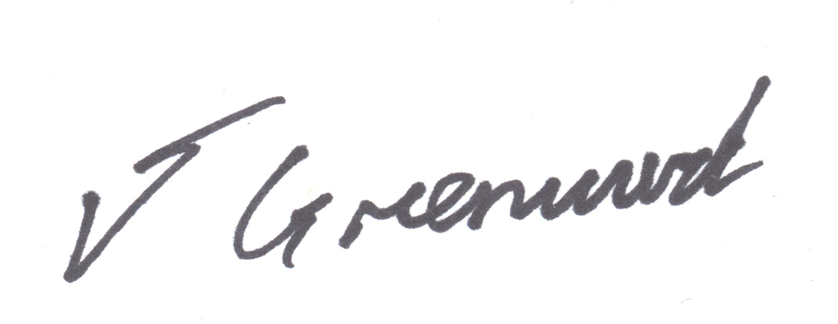

Dr Jason Greenwood
Director of Education

